**Spring Return Pneumatic Actuator**

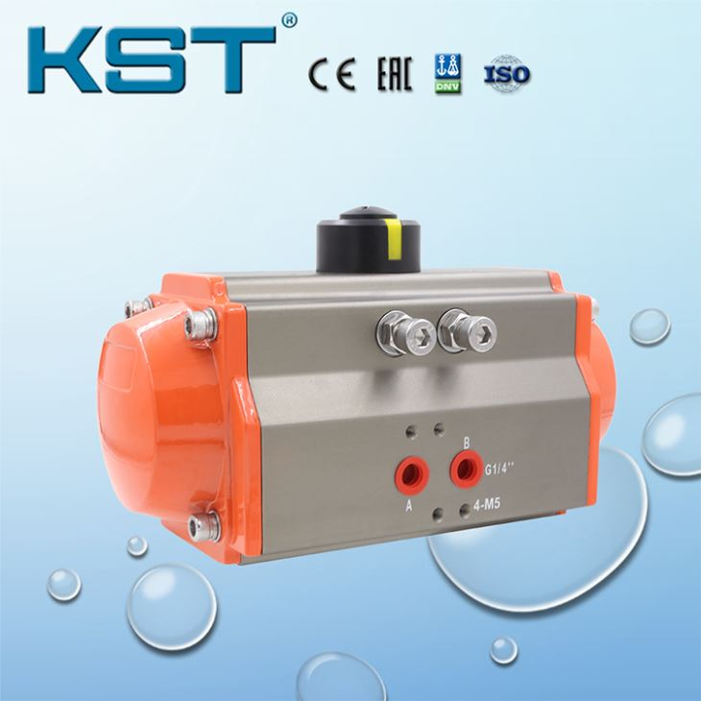



Spring Return Pneumatic Actuator of Kangsaite Automation Group Co.,Ltd.  
A.Rich production experience from 1997.  
B.Strong quality assurance with ISO/CE certificates etc.  
C.Self-research Team to ensure Pneumatic Actuator quality and research.  
D.Professional Sales Team for serving worldwide customers.

**Introduction**

The Spring Return pneumatic actuator controls the valve by the gear shaft rotating movement, which is driven by the meshing movement of the rack and the gear by the piston.

When the pressure of the air source enters the middle cavity between the two pistons of the cylinder from the air port, the two pistons are separated and moved toward the two ends of the cylinder, forcing the springs at both ends to compress, and the air in the air chambers at both ends is discharged through the air ports, and the two piston racks are synchronized Drive the output shaft to rotate counterclockwise. After the air source pressure is reversed by the solenoid valve, the two pistons of the cylinder move in the middle direction under the elastic force of the spring, and the air in the middle air cavity is discharged from the air port, and at the same time, the two piston racks synchronously drive the output shaft to rotate clockwise.

**Features**

A. CE certificate and According with international Standards, such as NAMUR,ISO5211 and DIN.

B. Integrated Design with Stable Quality.

C. Dual Piston rack and Pinion Design with High Output Power.

D. Multi-position Indicator, On-site Visual Instruction.

E. The single-acting switching action is only air-driven and the closing action is spring-returned; single-acting is normally open and normally closed: Off gas off)

F. Only one end of the air intake (exhaust), the structure is simple, the air consumption is small.

G. Reset by spring force or diaphragm force. Part of the compressed air energy is used to overcome the spring force or diaphragm tension, thereby reducing the output force of the piston rod.

H. Springs, diaphragms, etc. are installed in the cylinder, and the stroke is generally short; compared with double-acting pneumatic actuators of the same volume, the effective stroke is smaller.

I. The tension of the cylinder return spring and the diaphragm changes with the deformation, so the output force of the piston rod changes during the travel.

|  |  |
| --- | --- |
| Product | Spring Return Pneumatic Actuator |
| Structure | Rack and Pinion Rotary Actuator |
| Rotary Angle | 0-90 Degree |
| Air Supply Pressure | 2.5-8 Bar |
| Actuator Body Material | Aluminum Alloy |
| Surface Treatment | Hard Anode Oxidation |
| Operating Temperature | Standard Temperature:-20℃ ~ 80℃  Low Temperature:-15℃ ~ 150℃  High Temperature:-35℃ ~ 80℃ |
| Connection Standard | Air interface: NAMUR  Mounting Hole: ISO5211 & DIN3337(F03-F25) |
| Application | Ball Valve, Butterfly Valve & Rotary Machines |
| Cover Color | Blue,Black,Orange,Red & Customized Colors as Customer needs |

