**CRYODAM-S**

**Valves for cryogenics LIN - LAR**

**Direct operated valves**

|  |  |
| --- | --- |
| Series | **CRYODAM-S-(size)** |
| Function | **2/2 way normally closed** |
| Operation | **Direct** |
| Body | **Brass / SS304** |
| Seal | **PTFE** |
| Temperature | **-196 + 180°C** |
| Ambient Temperature | **-20 + 50°C** |
| Pressure min-max | **0 – 10Bar** |
| Coil | **IP65 100% ED 24VDC 24VAC50Hz 230VAC50Hz** |
| Tolerance | **10%** |
| Power | **50W(DC) 50VA (AC)** |
| Available orifices | **15 – 20 – 25mm** |
| Connections | **½” – ¾” – 1”** |
| Circuit Diagram |  |
| Media | **LIN-LAR** |

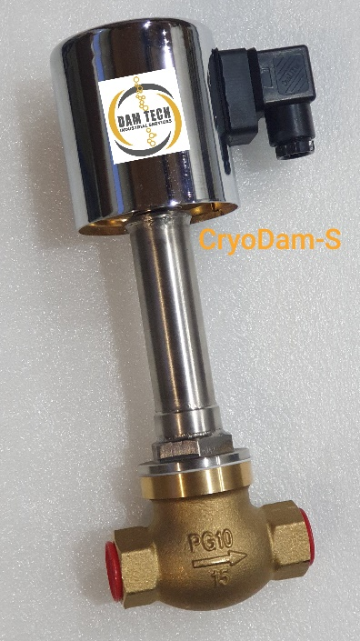



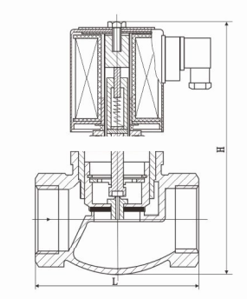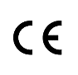Dimensions in mm

|  |  |  |  |
| --- | --- | --- | --- |
| Sizes | ½” | ¾” | 1” |
| L | 86 | 94 | 105 |
| H | 278 | 280 | 297 |
| Kg | 2.7 | 2.8 | 3.9 |
|  |  |  |  |
| Kv m³/h | 3.6 | 7.8 | 11.2 |

**Safety instructions**

*This product is not a safety device and may not be used as such.

*Damage caused by improper operating conditions or other reasons, may cause improper functioning of the solenoid.

*Correct transport, proper storage and installation, and proper use and maintenance, are essential for reliable and error-free operation.

*It is the responsibility of the user to select the right product for the application.

*The product may not function properly as a result of dirt, wear, damage (for example, by dropping) or improper use. Therefore, the product should not be used in applications where a malfunction can cause danger or damage.

*This product is not intended or approved for medical applications, food and/or application in explosive gas appliances.

*Solenoid valves can only be used with clean liquids or gases.

*It is recommended to install a filter before the solenoid valve.

*Check the compatibility of the medium used, temperature and other operating conditions with the materials and specifications of the product.

*Never exceed the limits for pressure, temperature or voltage as indicated on the product and/or in the technical documentation.

*The temperature of a solenoid valve coil can rise during operation; this is normal. Overheating will cause smoke and a burning smell. In this case, the power supply must immediately be disconnected.

*Warning: a valve opens and closes quickly. Improper use can cause pressure transients (fluid hammer) in the pipes with possible damage as a consequence.

*It is not allowed to change the construction valve.

*Beware of electric shock when working with electrical equipment.

**Installation and Maintenance**

**Safety before starting**

*It is recommended to install the product in a dry environment. In moist environments, make sure that no moisture can penetrate the coil, actuator or connector. Install the solenoid valve in a safe way to avoid electric shock, burning or other injuries. Ensure that the solenoid valve is installed in an area with adequate ventilation to facilitate heat dissipation. Make sure the solenoid valve is not in contact with or in the vicinity of flammable materials. Ensure that the product is protected clean.

* Operations may only be performed when the system is not pressurized, electrically disconnected and cooled down.

* Turn off the power supply before performing any work on the solenoid valve to prevent the risk of electrical shock and to prevent activation of the solenoid valve.

* The product is only safe when properly installed and operated by qualified persons. Please read the safety instructions and technical documentation carefully before installation, use or maintenance.

* Always make sure to start the installation safely after installation or maintenance.

* Water hammer is a typical consequence of a high flow rate and pressure in pipes with small diameters. There are several solutions to this problem:

- Reduce the pressure with a pressure reducing valve before the solenoid valve.

- Increase the pipe diameter if possible.

- Dampen the water hammer by using a flexible hose or buffer before the solenoid valve.

**Installation**

*Clean fluids and gases The solenoid valve can be used in combination with clean liquids or gases. Make sure that the pipe may contain dirt before installing the valve. It is recommended to install a filter (500 μm) before the solenoid valve.

* Be aware of the direction of flow of the medium when installing the valve. Solenoid valves with an arrow on the housing must be connected in the indicated direction. The pipes on both sides of the valve must be securely fastened. Use a wrench for both valve and pipe while tightening to prevent unnecessary stresses in the system. The solenoid valve must be fixed via the provided connection points. Only exert force at the designated areas on the body such as the hexagon; never to the coil or armature. Avoid vibration in the pipes. Use a suitable sealant for threaded connections of the solenoid valve. Avoid the entry of thread sealing material in the valve, this can lead to malfunctioning of the valve.

* Install the solenoid in vertical position with the coil facing upwards.

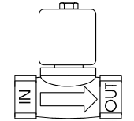  
 It is recommended to tighten the seal after the first cold setting.

Only in vertical position!

Be aware of the flow direction!

*Make sure the coil is labelled with the valve characteristics. The device can be damaged by the use of unsuitable tools.

* The temperature of the coil increases during use, this is normal. Overheating will cause smoke and a burning smell. In this case, the power supply must be shut down immediately.

* The coils can be rotated if the coil nut is loosened. After the determination of the correct position, the nut should be fastened with a torque of 5Nm.

* Verify the voltage and frequency before connecting the coil.

*Never connect power to the coil when it is not attached to the solenoid valve! The coil may burn out.

* Only connect power if you are sure that there is no pressure in the system and no hazardous situations can occur.

**Disposal**

The removal of the product should be performed in accordance with the applicable laws. Keep in mind the media that are still present in the valve.

Dam Tech bvba assumes no responsibility for any errors that may appear in this document