Limit Switch
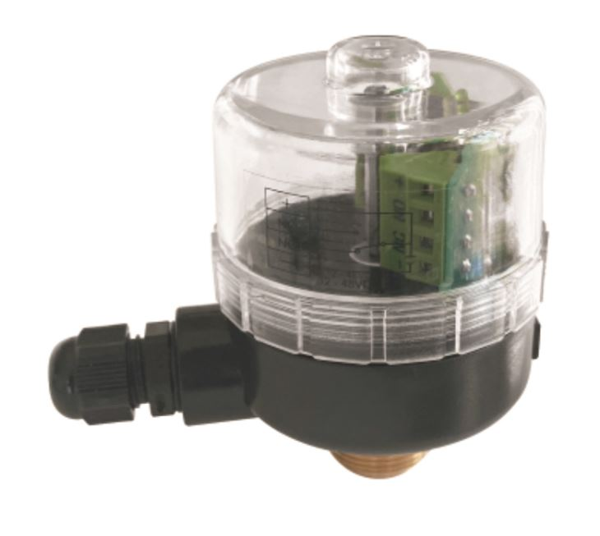

Linear Stroke Limit Switch Box of Kangsaite(KST) Automation Group Co.,Ltd.
A.Rich production experience from 1997.
B.Strong quality assurance with ISO/CE certificates etc.
C.Self-research Team to ensure Antibiotic Globe Valve quality and research.
D.Professional Sales Team for serving worldwide customers.
E.MOQ: 50pcs or Negotiation; Price Term: EXW, FOB, CFR, CIF; Payment: T/T, L/C.

Discription
DSL 616P Linear stroke position indicator can be directly mounted on angle seat valve and diaphragm valve,which can give feedback of valve position and remote report valve position. Built-in LED light can give very easy-spotting position feedback. Feedback unit can be installed a water-proof compact cover and assembled on valve with 360°rotation.

Features
◆ Easy assembly
◆ Open/close cam can be automatically adjusted according to stroke level
◆ LED light indicates operation is ready and gives position feedback
◆ Water-proof,clear and transparent cover
◆ Other feedback signal is available
◆ Various applicable occasions

Structure
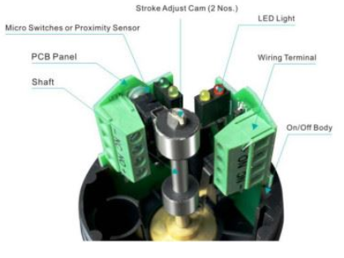

Technical parameters
